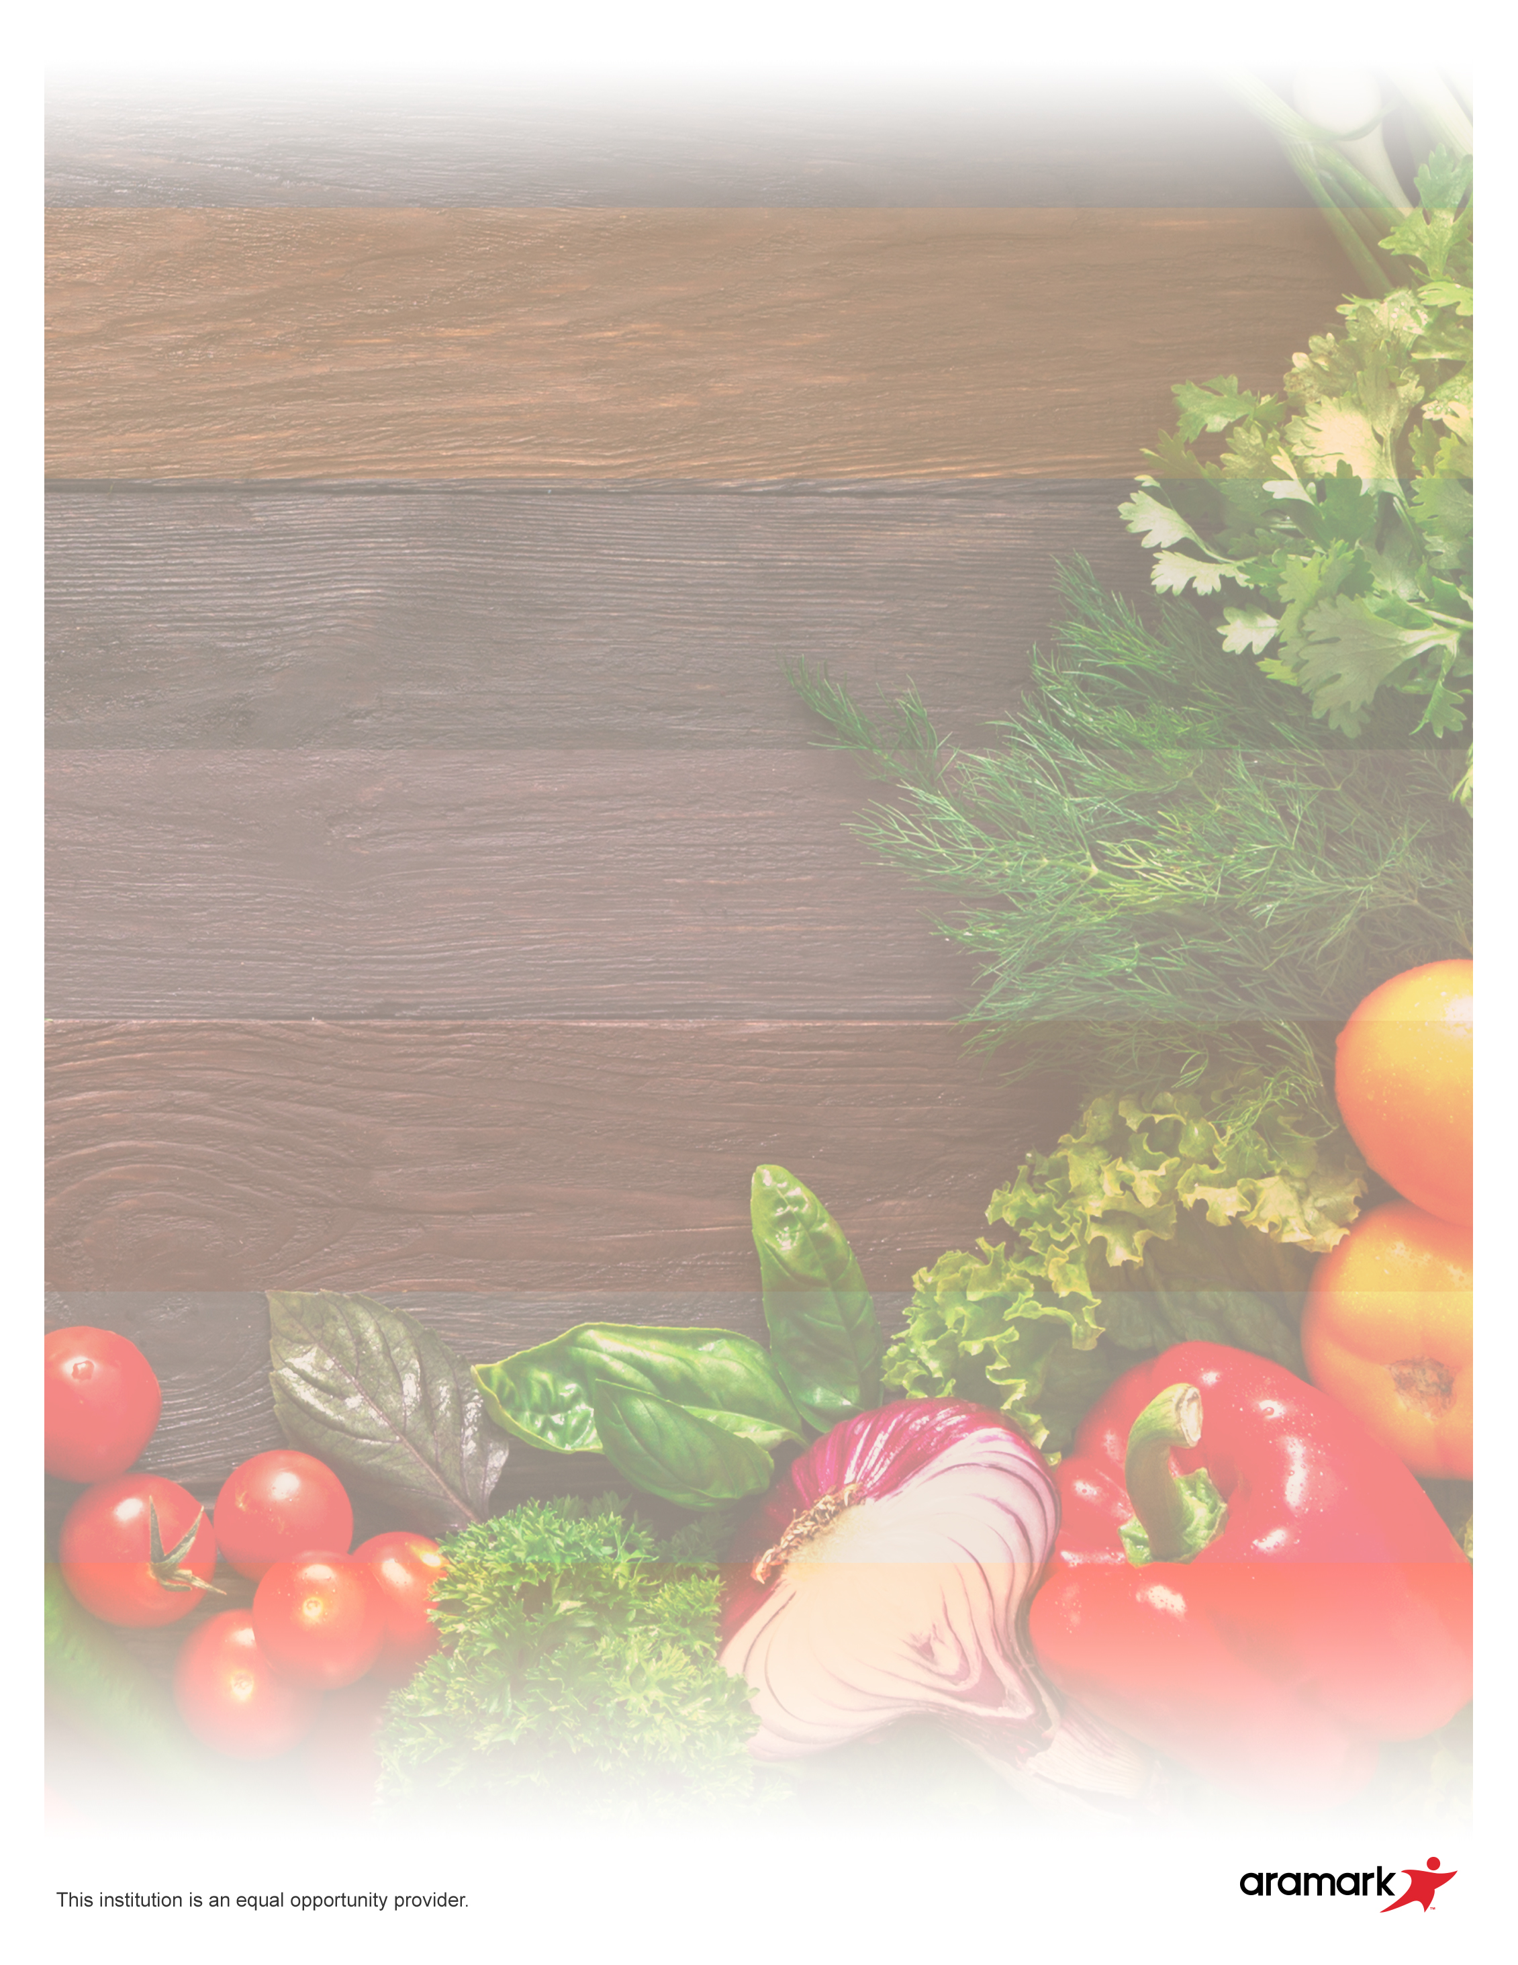

**PIZZA**

**M: Pepperoni**

**T: Cheese**

**W: Meat Lover’s**

**TH: BBQ Chicken**

**F: Manager’s Choice**

**Weekly Breakfast**

**Monday – French Toast**

**Tuesday – Muffin**

**Wednesday – Pancake Wrap**

**Thursday – Benefit Bar**

**Friday – Cream Cheese Bagel**

Meatball Sub

Fresh Carrots, Assorted Fruit

**31**

Pepperoni Pizza

Coleslaw, Assorted Fruit

**24**

Beef Tacos (2)

Kickin’ Beans, Assorted Fruit

**25**

Country Fried Steak Sandwich

Carrots, Assorted Fruit

**26**

Chicken Mashed Potato Bowl w/ Roll

Green Beans, Assorted Fruit

**27**

Cheeseburger

French Fries, Assorted Fruit

**28**

Pizza Burger

Broccoli, Assorted Fruit

**17**

Burrito

Campfire Beans, Assorted Fruit

**18**

Hot Dog

Cauliflower, Assorted Fruit

**19**

Boneless Chicken Wings w/ Roll

Fresh Carrots, Assorted Fruit

**20**

Breakfast for Lunch

Waffle w/ Sausage

Tater Tots,

Assorted Fruit

**21**

Chicken Drumstick w/ Roll

Steamed Carrots, Assorted Fruit

**10**

Crispito

Mexicali Corn, Assorted Fruit

**11**

Calzone

Tomato Cucumber Salad, Assorted Fruit

**12**

Popcorn Chicken w/ Roll

Broccoli, Assorted Fruit

**13**

BBQ Rib Sandwich

Baked Beans, Assorted Fruit

**14**

Chicken Tenders w/ Roll

Corn, Assorted Fruit

**3**

Beef Nachos

Charro Beans, Assorted Fruit

**4**

Bacon Cheeseburger

Coleslaw, Assorted Fruit

**5**

Corn Dogs

Fresh Carrots,

Assorted Fruit

**6**

Pizza Sticks w/ Marinara

Green Beans, Assorted Fruit

**7**

**Daily Options:**

**-Chicken Patty Sandwich**

**-Pizza**

In addition, 1% or Flavored Milk Available Daily

**\*MENU IS SUBJECT TO CHANGE**

**Purdue Polytechnic Main Campus**

**August 2020**